1. CHARACTER STUFFING

#include<stdio.h>

#include<conio.h>

#include<string.h>

int main()

{

char a[100],b[100],c[100];

int i,j=0,n,k=0;

printf("Enter the data");

gets(a);

n=strlen(a);

for(i=0;i<n;i++)

{

if((a[i] == 'd' && a[i+1]=='l' && a[i+2]=='e')||

(a[i] == 'e' && a[i+1]=='s' && a[i+2]=='c'))

{

c[k++] = 'e';

c[k++] = 's';

c[k++] = 'c';

}

c[k++] = a[i];

}

c[k++] = '\0';

b[j++]='\0';

printf("%s\n",b);

printf("DLESTX");

printf("%s",c);

printf("DLEETX");

return 0;

}

**OUTPUT:**

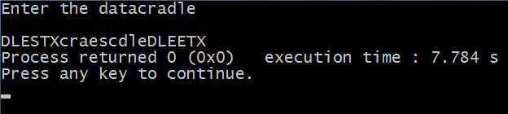

1. BIT STUFFING

#include<stdio.h>

#include<conio.h>

void main()

{

int a[15];

int i,j,k,n,c=0,pos=0;

printf("\n enter the no of bits");

scanf("%d",&n);

for(i=0;i<n;i++)

scanf("%d",&a[i]);

for(i=0;i<n;i++)

{

if(a[i]==1)

{

c++;

if(c==5)

{

pos=i+1;

c=0;

for(j=n;j>=pos;j--)

{

k=j+1;

a[k]=a[j];

}

a[pos]=0;

n=n+1;

}

}

else

c=0;

}

printf("\n data after stuffing");

printf("011111110");

for(i=0;i<n;i++)

{

printf("%d",a[i]) ;

}

printf("011111110");

getch();

}

**OUTPUT:**

|  |
| --- |
|  |